Cinderella’s Castle  stEM Lesson | Grade Level: 3 and 4
Lesson Objective:  Students will identify geometric shapes and will understand that each shape is part of the whole castle, expressing this as a fraction. | Benchmark Standard:  MAFS.3.NF.1.1  Understand a fraction 1/b as the quantity formed by 1 part when a whole is partitioned into b equal parts; understand a fraction a/b as the quantity formed by a parts of size 1/b.  MAFS.4.G.1.3  Recognize a line of symmetry for a two-dimensional figure as a line across the figure such that the figure can be folded along the line into matching parts. Identify line-symmetric figures and draw lines of symmetry.
Essential Question:  What fraction of your castle is made from each shape?  What is symmetry? | Vocabulary:  Fraction  Symmetry  Square  Rhombus  Hexagon  Triangle  Trapezoid  Quadrilateral | Vocabulary Activities:  Identify each shape  Identify the fraction of the whole that each shape makes up  Model symmetry using pattern blocks
Preparation Directions: Copy Cinderella’s Castle worksheet for each student. Prepare a container of pattern blocks for each student or small group of students.  Engage: Read or tell the story of Cinderella or a summary. Explain that now that Cinderella is married she wants to become an architect. Her first project will to build her own castle. She would like you to share your castle building ideas with her to help her plan for her castle construction.  Share the Career page about becoming an architect.  Procedures:  Teach or review symmetry. This can be modeled using pattern blocks.  Provide a visual of the shapes with their names and definitions. | Materials:  Pattern blocks  Labeled pictures of the shapes with names of the shapes.  Sample Questions:  How many blocks did you use?  What fraction of the blocks are ___(triangles, rhombuses, hexagons, etc.)  Where is your castle’s line of symmetry?  How many lines of symmetry does this castle have?
Assessment:
Students should be able to label their castle with the fractions of each shape it is made from.
Students should build a symmetrical castle and be able to identify its line of symmetry.
Additional Resources:

Becoming an Architect
We all need places to live, work, play, shop and eat - and it wouldn't be possible without the work of architects. If you're interested in watching your ideas turn into buildings, then read on to find out how to become an architect!

Architects - What Do Architects Do?
Architects design homes, office buildings, schools, hospitals, sports arenas, shopping malls and so much more. Although the appearance of these buildings are important, architects need to consider other factors, like building costs and function, and make sure they pass three tests.
- The building must be safe for people to use.
- The building must serve the purpose for which it was designed for.
- The building must be pleasing to the senses.
In order to design such a building, you'll need to get educated in the liberal arts and sciences.

Architects - How Can I Become an Architect?

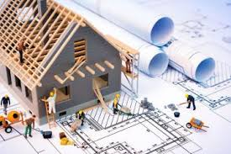
Since architecture is the art AND science of building design, you need to take a variety of courses in high school, like English, history, business, computer science, physics, math(geometry, trigonometry, algebra and calculus) and art (drawing, painting, sculpture and photography).
Once you graduate from high school, you need to earn a degree in architectures at an architectural school that's recognized by the National Architectural Accrediting Board (NAAB). Then you'll have to gain practical work experience by working under a licensed architect, work as an intern in the Intern Development Program (IDP), take and pass a national exam called the ARE, and apply for a certificate issued by the National Council of Architectural Registration Boards (NCARB), which allows you to practice architecture in both the US and Canada. That's quite a mouthful, but getting past all those steps will have you on your way to a rewarding (and well-paying) career!

Architects - Did U Know?
- Architects can earn anywhere from $35,000 to $93,000 US.
- More than 1 in 5 architects are self-employed.
- In North America, the initials RA designate a registered or licensed architect.

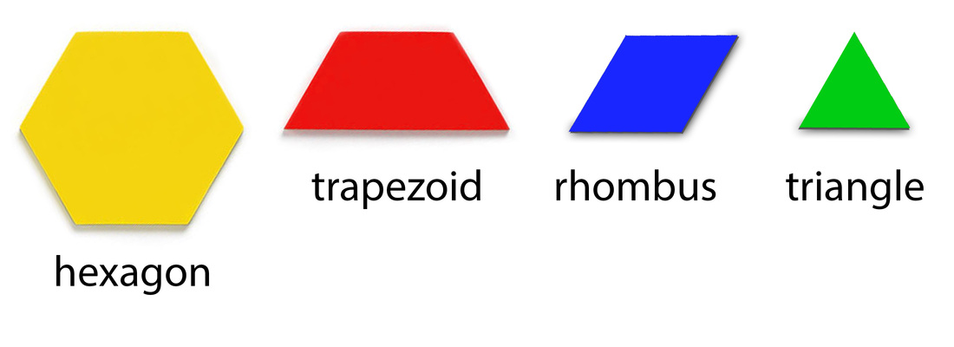
Cinderella’s Castle
Challenge: Can you build Cinderella’s new castle out of pattern blocks? Make sure the castle has at least one line of symmetry.

Write a fraction to represent each shape’s portion of the whole castle.

________ squares ________ rhombuses ________ hexagons________ triangles ________ trapezoids_____quadrilaterals

